Terraform

template

-IAAS

-Automation tool

hashcorp-maintaining the terraform

TERRAFORM WORKFLOW

-fundamental bloc

-variable block

-online/calling block.

#terraform init

#terraform validate

#terraform plan

#terraform apply

#terraform destroy

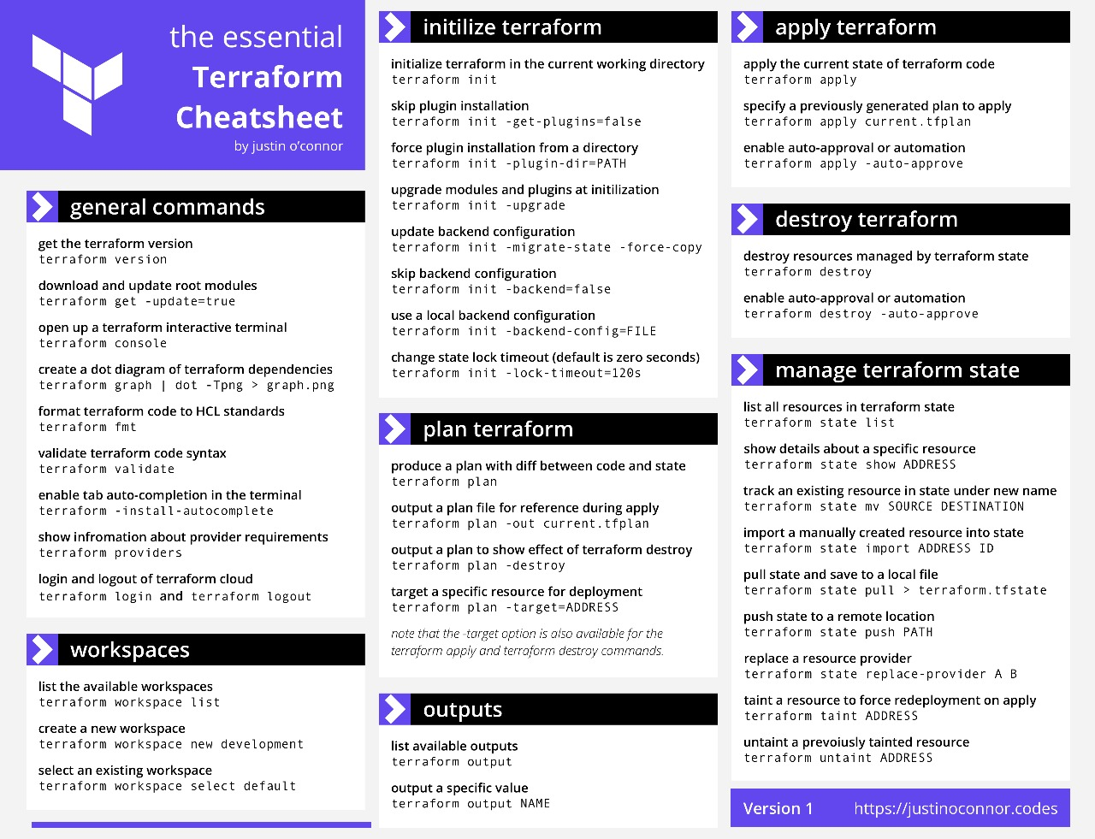

CODE:

region = "us-east-1"

terraform {

required_providers {

aws = {

source = "hashicorp/aws"

version = "~> 5.0"

}

}

}

# Configure the AWS Provider

provider "aws" {

region = "us-east-1a"

resource "aws_vpc" "myvpc" {

cidr_block = "10.0.0.0/16"

tags = {

Name = "demovpc"

  }

}

# Create a VPC

resource "aws_vpc" "example" {

cidr_block = "10.0.0.0/21"

}

# Configure the AWS Provider

provider "aws" {

version = "~> 5.0"

region = "us-east-1b"

resource "aws_subnet" "pubsub" {

vpc_id = aws_vpc.myvpc.id

cidr_block = "10.0.1.0/24"

availability_zone = "us-east-1a"

tags = {

Name = "sn1"

  }

}

}

# Create a VPC

resource "aws_vpc" "example" {

cidr_block = "10.0.0.0/22"

resource "aws_internet_gateway" "tfigw" {

vpc_id = aws_vpc.myvpc.id

tags = {

Name = "tfigw"esource "aws_route_table" "tfprirt" {

vpc_id = aws_vpc.myvpc.id

route {

cidr_block = "0.0.0.0/0"

gateway_id = aws_nat_gateway.tfnat.id

}

tags = {

Name = "tfprivateroute"

  }

}

  }

}

resource "aws_route_table" "tfpubrt" {

vpc_id = aws_vpc.myvpc.id

route {

cidr_block = "0.0.0.0/0"

gateway_id = aws_internet_gateway.tfigw.id

}

tags = {

Name = "tfpublicroute"

  }

}

resource "aws_route_table_association" "pubsn1" {

subnet_id = aws_subnet.pubsub.id

route_table_id = aws_route_table.tfpubrt.id

}

resource "aws_route_table_association" "pubsn2" {

subnet_id = aws_subnet.pub_sub.id

route_table_id = aws_route_table.tfpubrt.id

}

resource "aws_eip" "tfeip" {

domain = "vpc"

}

resource "aws_nat_gateway" "tfnat" {

allocation_id = aws_eip.tfeip.id

subnet_id = aws_subnet.pub_sub.id

tags = {

Name = "gw NAT"

  }

}

}

resource "aws_route_table_association" "prisn3" {

subnet_id = aws_subnet.prisub.id

route_table_id = aws_route_table.tfprirt.id

}

resource "aws_route_table_association" "prisn4" {

subnet_id = aws_subnet.pri_sub.id

route_table_id = aws_route_table.tfprirt.id

}

resource "aws_security_group" "allow_tfsg" {

name = "allow_tfsg"

description = "Allow TLS inbound traffic"

vpc_id = aws_vpc.myvpc.id

ingress {

description = "HTTPS "

from_port = 443

to_port = 443

protocol = "tcp"

cidr_blocks = ["0.0.0.0/0"]

}

ingress {

description = "HTTP "

from_port = 80

to_port = 80

protocol = "tcp"

cidr_blocks = ["0.0.0.0/0"]

}

ingress {

description = "SSH"

from_port = 22

to_port = 22

protocol = "tcp"

cidr_blocks = ["0.0.0.0/0"]

}

egress {

from_port = 0

to_port = 0

protocol = "-1"

cidr_blocks = ["0.0.0.0/0"]

}

tags = {

Name = "TfsecurityGroup"

  }

}

resource "aws_instance" "pub_ins" {

ami = "ami-0fc5d935ebf8bc3bc"

instance_type = "t2.micro"

subnet_id = aws_subnet.pub_sub.id

vpc_security_group_ids = [aws_security_group.allow_tfsg.id]

key_name = "David"

associate_public_ip_address   =  "true"

}

resource "aws_instance" "pri_ins" {

ami = "ami-0fc5d935ebf8bc3bc"

instance_type = "t2.micro"

subnet_id = aws_subnet.prisub.id

vpc_security_group_ids = [aws_security_group.allow_tfsg.id]

key_name      = "David"

}